**Problem 1**

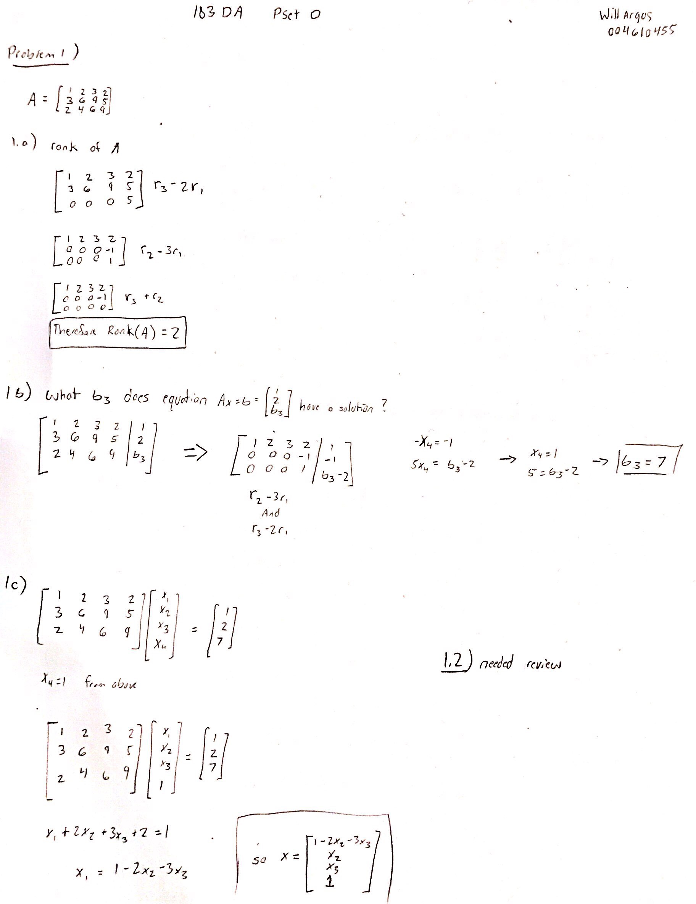

**Problem 2**

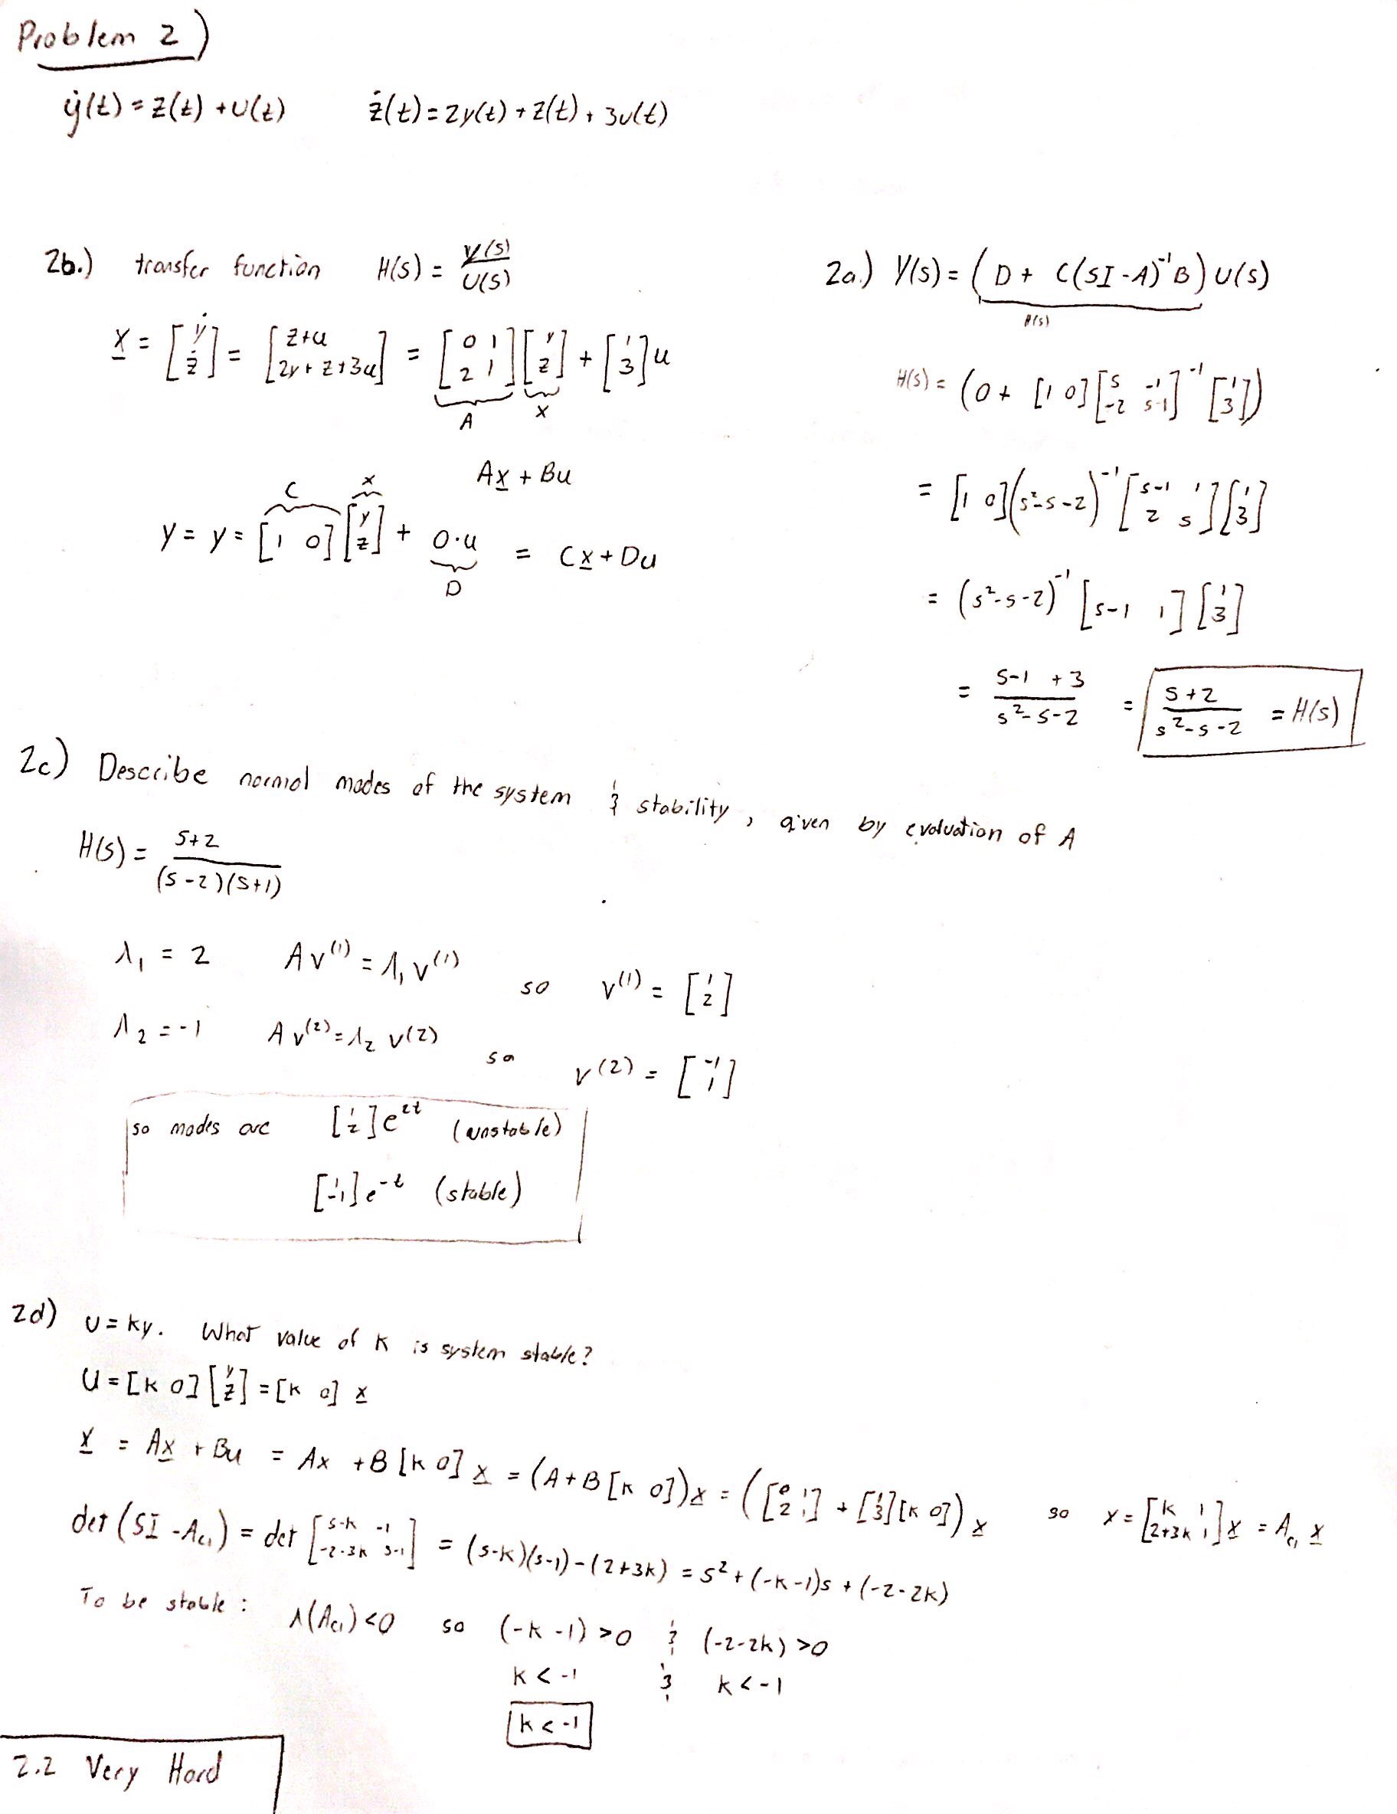

**Problem 3**

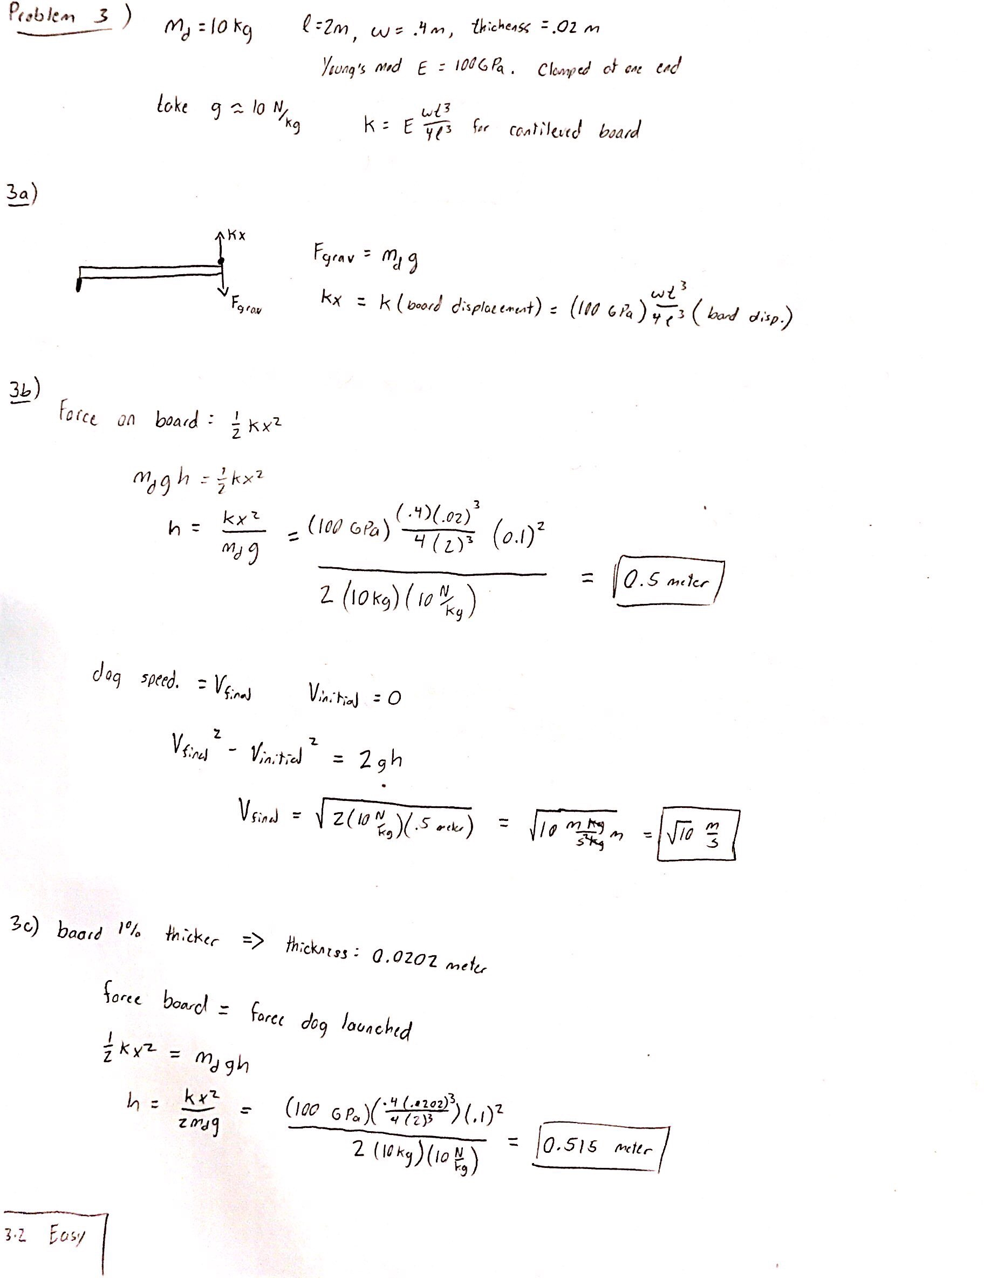

**Problem 4**

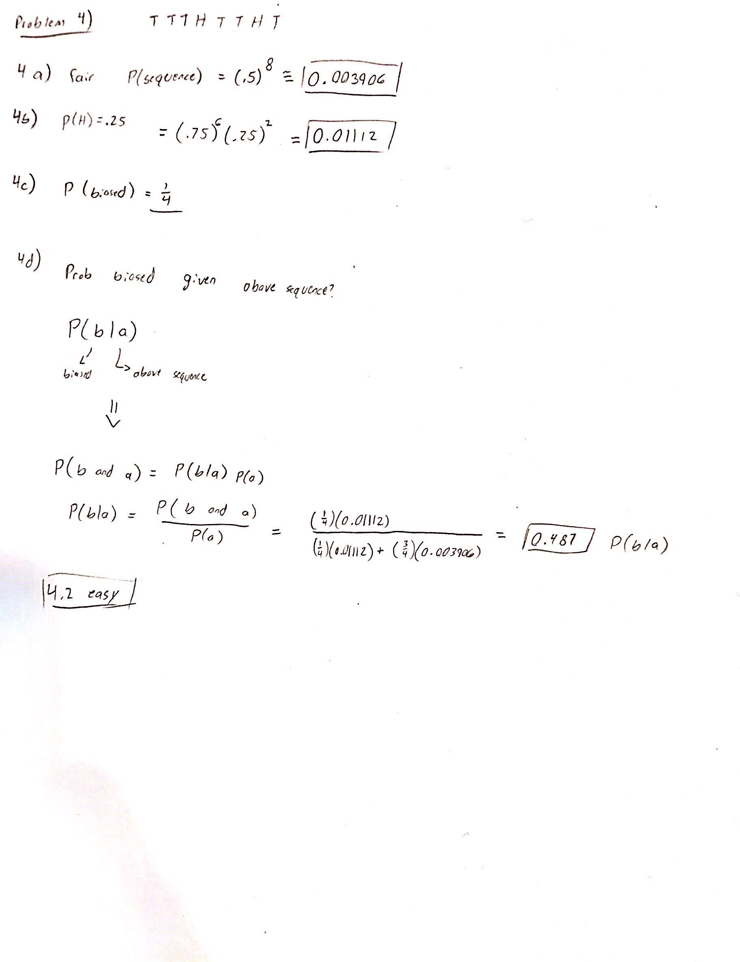

**Problem 5** (Code in Appendix)

**Part A)**

5 Sequences of 40 flops for a fair coin

|  |  |  |  |  |  |  |  |  |  |  |  |  |  |  |  |  |  |  |  |  |  |  |  |  |  |  |  |  |  |  |  |  |  |  |  |  |  |  |  |  |
| --- | --- | --- | --- | --- | --- | --- | --- | --- | --- | --- | --- | --- | --- | --- | --- | --- | --- | --- | --- | --- | --- | --- | --- | --- | --- | --- | --- | --- | --- | --- | --- | --- | --- | --- | --- | --- | --- | --- | --- | --- |
| 0 | 1 | 0 | 1 | 0 | 0 | 0 | 0 | 1 | 0 | 0 | 0 | 0 | 1 | 1 | 0 | 1 | 0 | 1 | 1 | 0 | 1 | 1 | 0 | 0 | 1 | 1 | 0 | 1 | 1 | 1 | 0 | 1 | 0 | 1 | 0 | 0 | 1 | 0 | 1 | 0 |
| 0 | 1 | 0 | 1 | 0 | 1 | 1 | 1 | 1 | 0 | 0 | 0 | 1 | 1 | 0 | 0 | 1 | 0 | 1 | 1 | 0 | 1 | 1 | 0 | 0 | 1 | 0 | 1 | 0 | 0 | 1 | 0 | 0 | 1 | 0 | 1 | 0 | 0 | 1 | 0 | 0 |
| 1 | 0 | 1 | 0 | 0 | 1 | 0 | 1 | 0 | 0 | 1 | 0 | 1 | 0 | 0 | 1 | 0 | 1 | 1 | 0 | 1 | 0 | 0 | 1 | 0 | 0 | 1 | 1 | 1 | 0 | 1 | 1 | 0 | 1 | 0 | 0 | 1 | 0 | 0 | 0 | 1 |
| 1 | 1 | 0 | 1 | 1 | 1 | 0 | 0 | 0 | 0 | 1 | 1 | 1 | 0 | 1 | 0 | 1 | 1 | 0 | 0 | 0 | 0 | 0 | 0 | 1 | 1 | 0 | 0 | 1 | 1 | 1 | 1 | 0 | 1 | 0 | 1 | 1 | 1 | 1 | 0 | 1 |
| 1 | 1 | 0 | 0 | 0 | 0 | 0 | 1 | 1 | 0 | 0 | 1 | 1 | 0 | 0 | 0 | 0 | 0 | 0 | 0 | 0 | 1 | 0 | 1 | 1 | 1 | 0 | 0 | 1 | 0 | 0 | 0 | 0 | 1 | 1 | 0 | 1 | 0 | 0 | 1 | 1 |
| 0 | 1 | 0 | 1 | 0 | 0 | 0 | 0 | 1 | 0 | 0 | 0 | 0 | 1 | 1 | 0 | 1 | 0 | 1 | 1 | 0 | 1 | 1 | 0 | 0 | 1 | 1 | 0 | 1 | 1 | 1 | 0 | 1 | 0 | 1 | 0 | 0 | 1 | 0 | 1 | 0 |

5 sequences of 40 flips for a biased coin

|  |  |  |  |  |  |  |  |  |  |  |  |  |  |  |  |  |  |  |  |  |  |  |  |  |  |  |  |  |  |  |  |  |  |  |  |  |  |  |  |  |
| --- | --- | --- | --- | --- | --- | --- | --- | --- | --- | --- | --- | --- | --- | --- | --- | --- | --- | --- | --- | --- | --- | --- | --- | --- | --- | --- | --- | --- | --- | --- | --- | --- | --- | --- | --- | --- | --- | --- | --- | --- |
| 0 | 0 | 1 | 1 | 0 | 1 | 0 | 1 | 0 | 0 | 0 | 0 | 0 | 1 | 0 | 1 | 0 | 0 | 0 | 1 | 0 | 0 | 1 | 0 | 1 | 0 | 0 | 0 | 0 | 0 | 0 | 0 | 0 | 0 | 0 | 0 | 0 | 1 | 0 | 0 | 0 |
| 0 | 1 | 1 | 0 | 1 | 0 | 1 | 0 | 0 | 1 | 0 | 1 | 0 | 1 | 0 | 1 | 1 | 0 | 1 | 0 | 1 | 1 | 0 | 0 | 0 | 0 | 0 | 0 | 0 | 0 | 1 | 0 | 0 | 0 | 0 | 0 | 1 | 0 | 0 | 0 | 0 |
| 0 | 1 | 1 | 0 | 0 | 0 | 0 | 1 | 0 | 0 | 0 | 0 | 0 | 0 | 0 | 0 | 1 | 0 | 0 | 0 | 0 | 0 | 0 | 0 | 0 | 0 | 0 | 0 | 1 | 1 | 0 | 0 | 0 | 0 | 0 | 0 | 0 | 0 | 0 | 0 | 0 |
| 0 | 1 | 0 | 0 | 1 | 0 | 0 | 0 | 0 | 0 | 0 | 0 | 0 | 0 | 0 | 1 | 0 | 0 | 0 | 0 | 1 | 0 | 0 | 0 | 0 | 0 | 1 | 0 | 0 | 1 | 0 | 0 | 1 | 0 | 0 | 0 | 1 | 1 | 0 | 0 | 0 |
| 1 | 0 | 0 | 1 | 0 | 0 | 0 | 0 | 0 | 1 | 0 | 0 | 0 | 0 | 0 | 0 | 0 | 1 | 0 | 0 | 1 | 0 | 0 | 0 | 0 | 0 | 1 | 1 | 0 | 0 | 0 | 0 | 0 | 0 | 0 | 0 | 1 | 0 | 0 | 1 | 1 |
| 0 | 0 | 1 | 1 | 0 | 1 | 0 | 1 | 0 | 0 | 0 | 0 | 0 | 1 | 0 | 1 | 0 | 0 | 0 | 1 | 0 | 0 | 1 | 0 | 1 | 0 | 0 | 0 | 0 | 0 | 0 | 0 | 0 | 0 | 0 | 0 | 0 | 1 | 0 | 0 | 0 |

**Part B)**

Likelihood coin is biased given coin is biased, over the course of each of the 5 sequences in part A

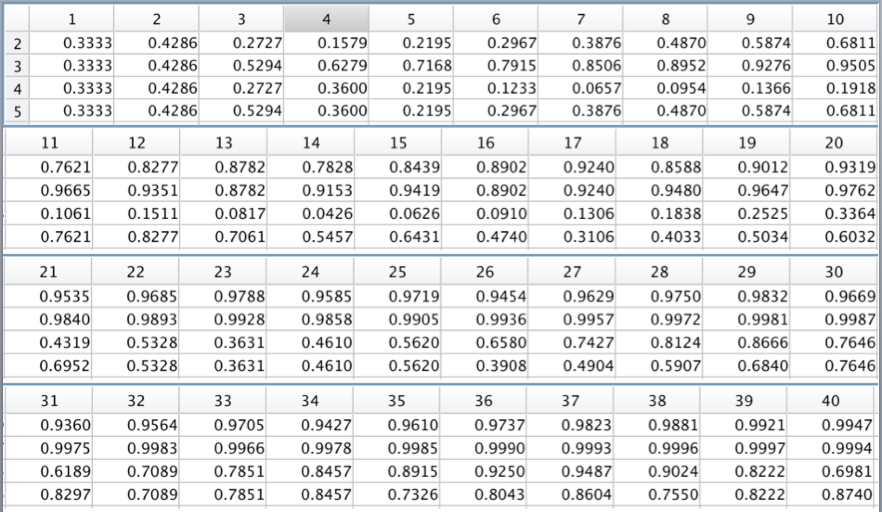

Likelihood coin is biased given coin is fair, over the course of each of the 5 sequences in part A

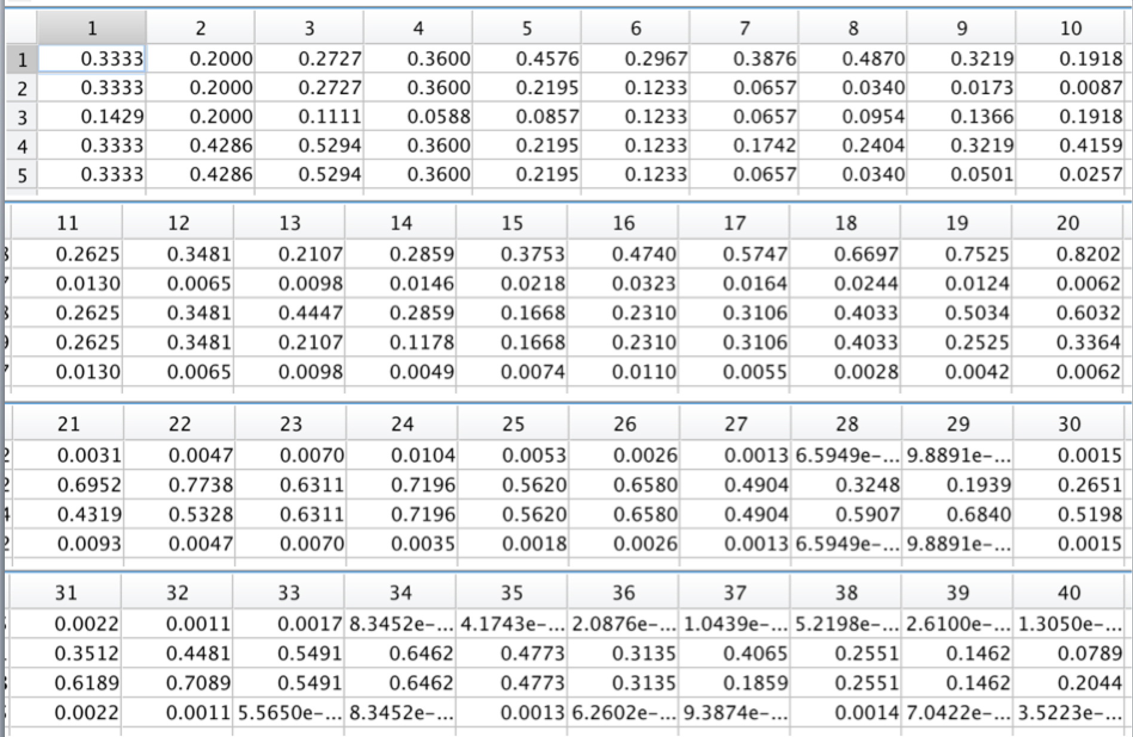

**Part C)**

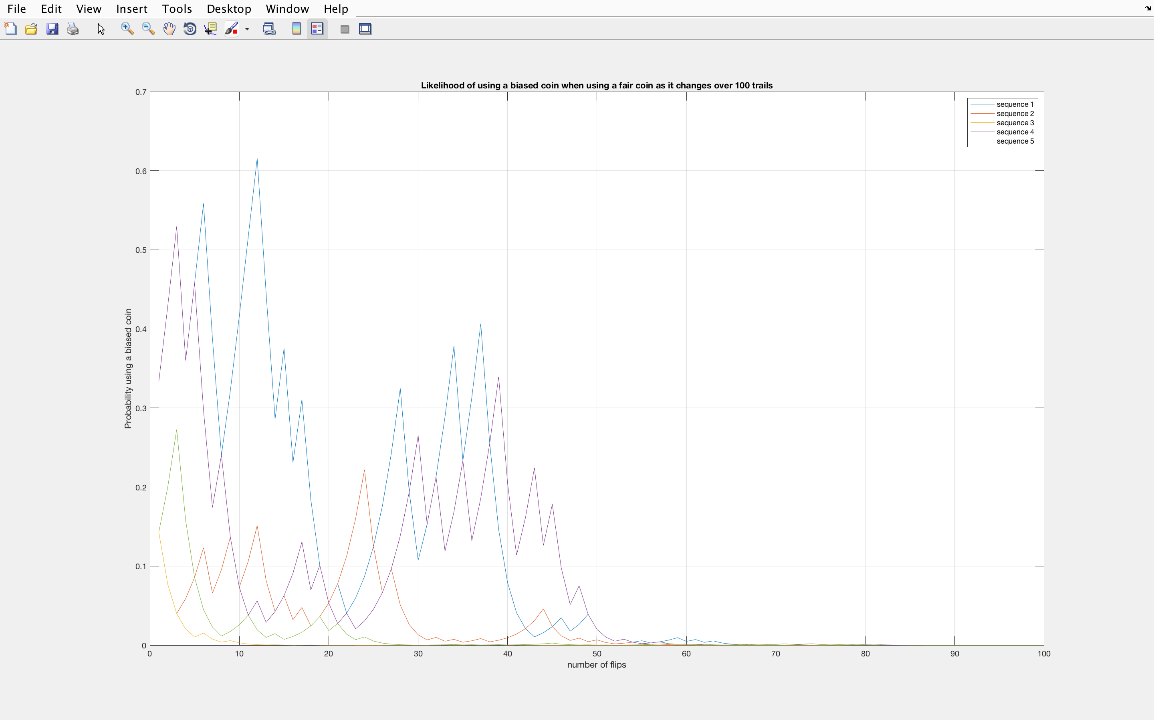

**Part D)**

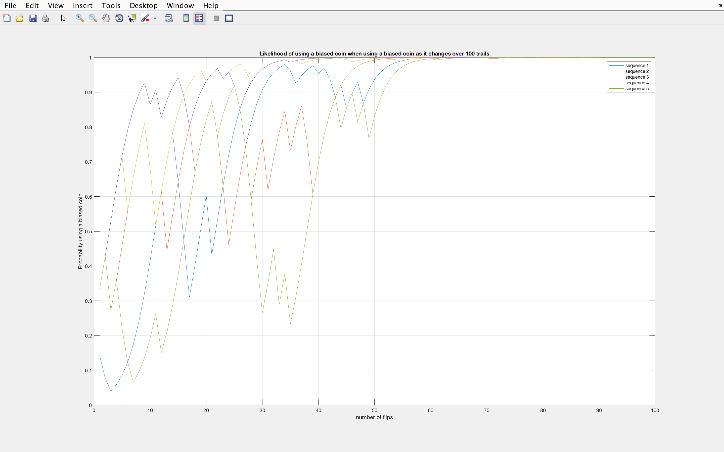

5.2: Hard

**Problem 6**

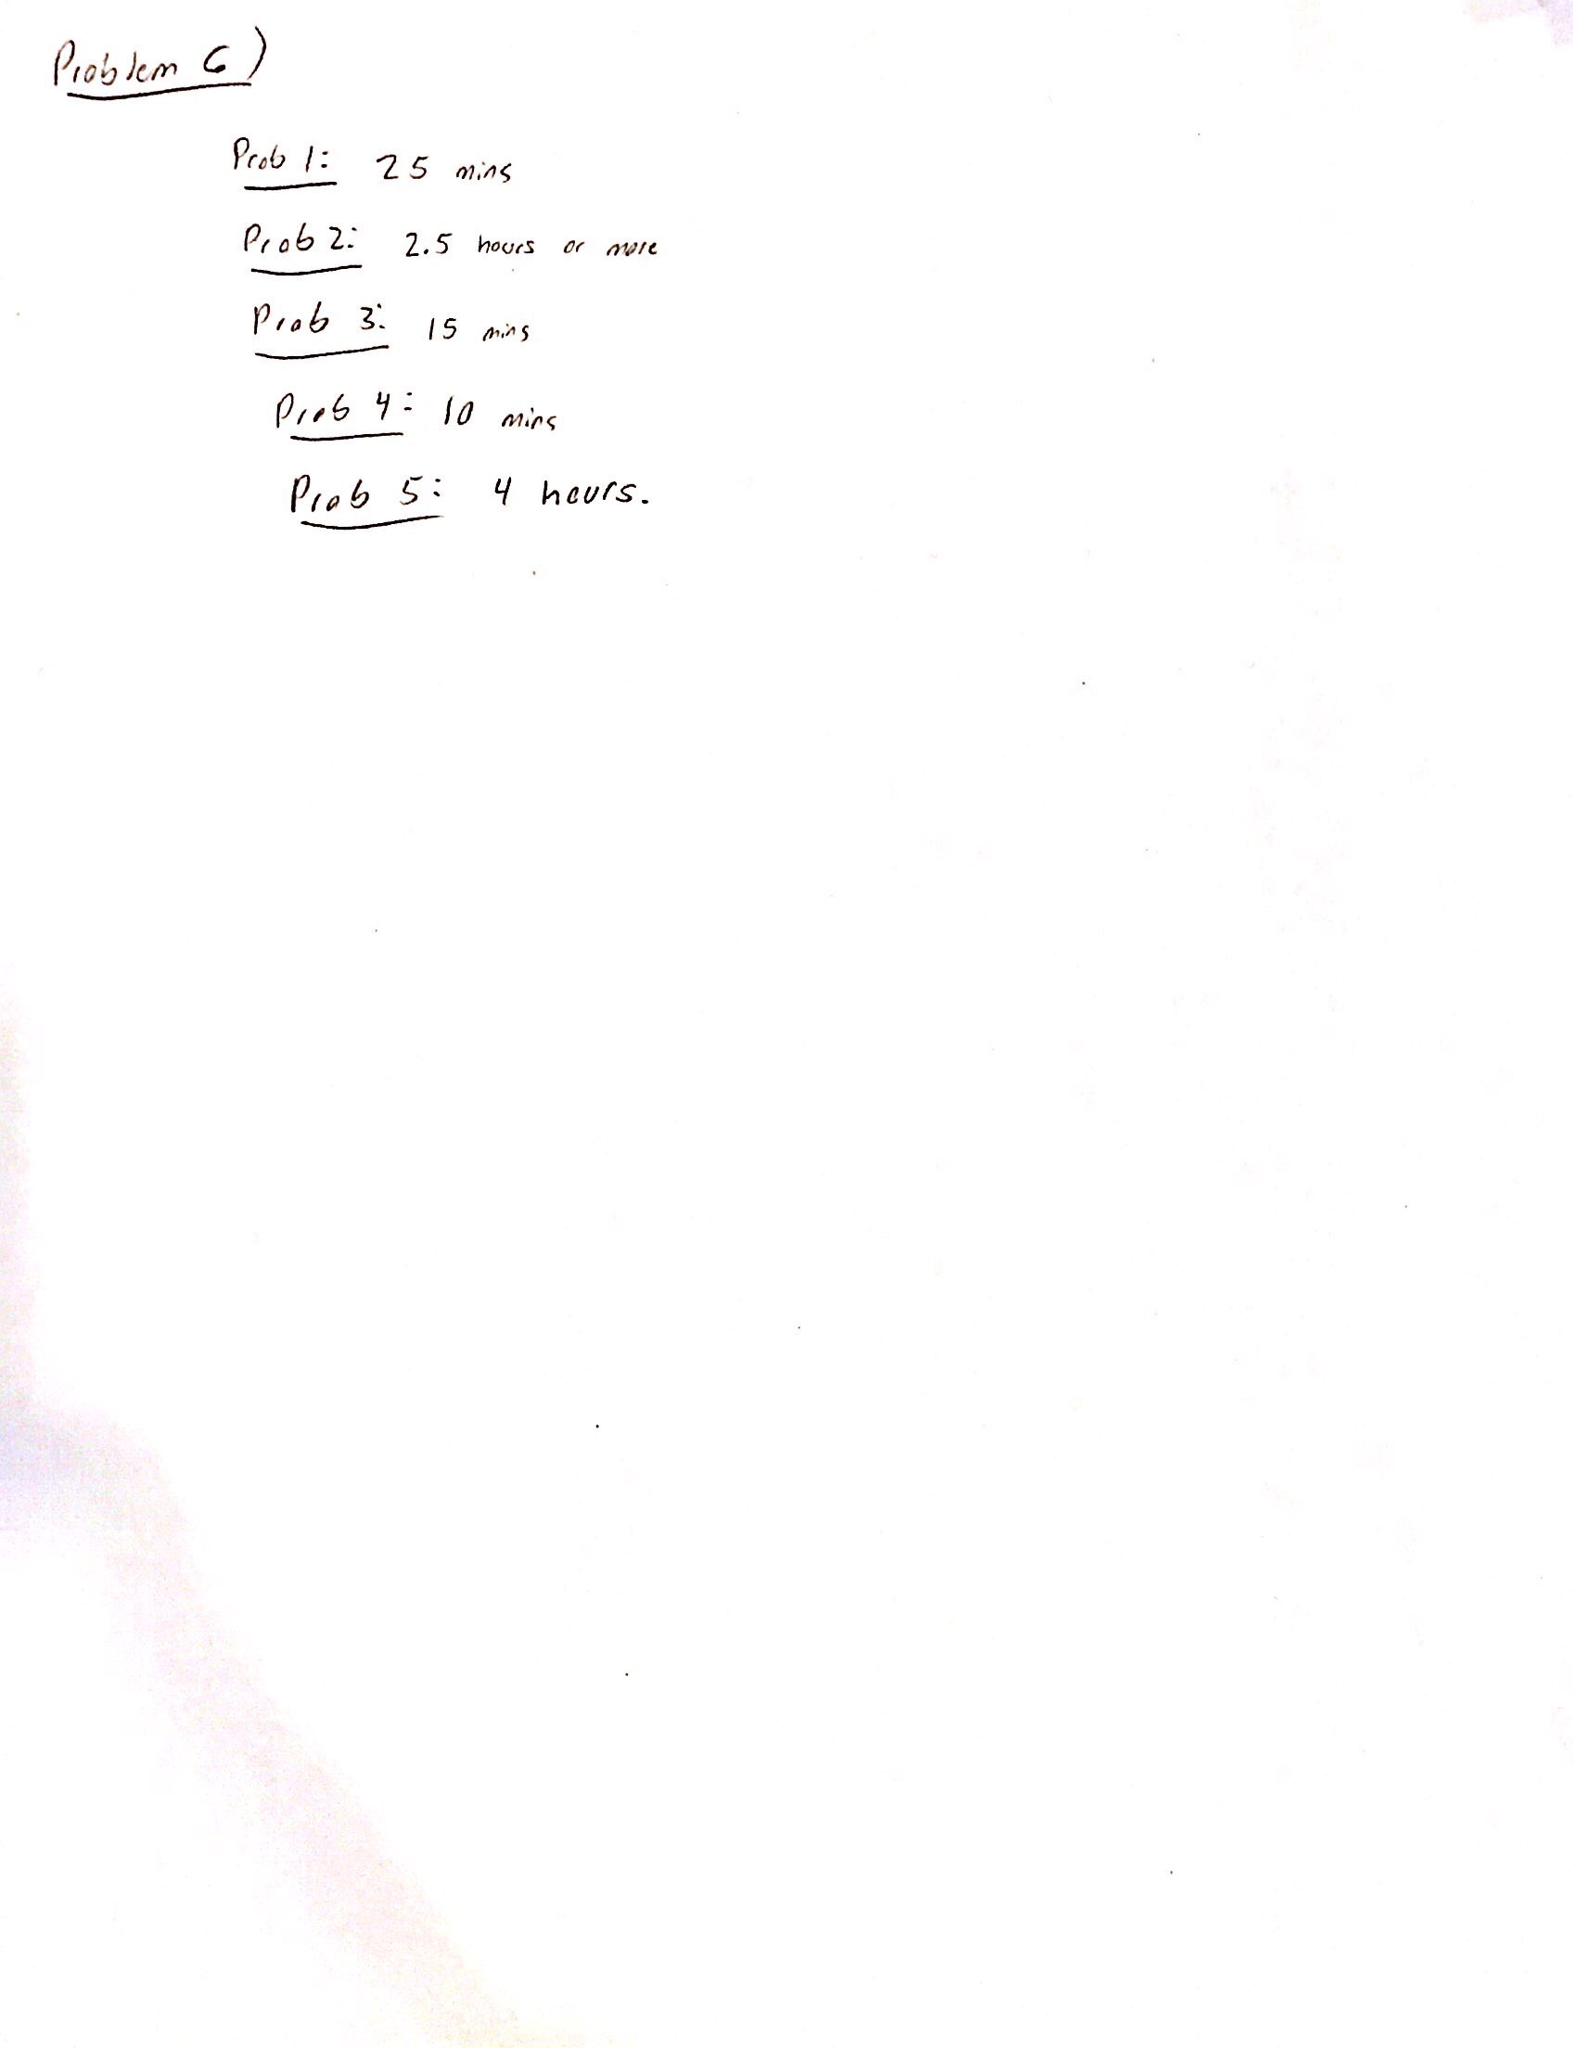

**Appendix**

clc; clear all; close all;

% 5a

% Fair

seqFair = [];

for i = 1:5

seqFairOutcome = cf(1,40);

seqFair(i,:) = seqFairOutcome;

end

% Biased

seqBiased = [];

for i = 1:5

seqBiasedOutcome = cf(2,40);

seqBiased(i,:) = seqBiasedOutcome;

end

% 5b

% Fair

seqFairB = [];

likeFairB = [];

for i = 1:5

[sequence_fair_b,likehood_fair_b] = cfl(1,40);

seqFairB(i,:) = sequence_fair_b;

likeFairB(i,:) = likehood_fair_b;

end

% Biased

seqBiasedB = [];

likeBiasedB = [];

for i = 1:5

[sequence_bias_b,likehood_bias_b] = cfl(2,40);

seqBiasedB(i,:) = sequence_bias_b;

likeBiasedB(i,:) = likehood_bias_b;

end

% 5c

seqFairC = [];

likeFairC = [];

for i = 1:5

[sequence_fair_c,likehood_fair_c] = cfl(1,100);

seqFairC(i,:) = sequence_fair_c;

likeFairC(i,:) = likehood_fair_c;

end

figure();

for i = 1:5

plot(1:100,likeFairC(i,:));

hold on;

end

hold off;

xlabel('number of flips');

ylabel('Probability using a biased coin');

title('Likelihood of using a biased coin when using a fair coin as it changes over 100 trails');

legend({'sequence 1','sequence 2','sequence 3','sequence 4','sequence 5'});

grid on;

% 5d

seqBiasedD = [];

likeBiasedD = [];

for i = 1:5

[sequence_bias_d,likehood_bias_d] = cfl(2,100);

seqBiasedD(i,:) = sequence_bias_d;

likeBiasedD(i,:) = likehood_bias_d;

end

figure();

for i = 1:5

plot(1:100,likeBiasedD(i,:));

hold on;

end

hold off;

xlabel('number of flips');

ylabel('Probability using a biased coin');

title('Likelihood of using a biased coin when using a biased coin as it changes over 100 trails');

legend({'sequence 1','sequence 2','sequence 3','sequence 4','sequence 5'});

grid on;

% 5a Fn

function seq = cf(cointype,numFlip)

switch cointype

% fair

case 1

seq = (rand(1,numFlip) < 0.5); % heads prob =0.5

% biased

case 2

seq = (rand(1,numFlip) < 0.25); % heads prob = 0.25

end

end

% 5b Fn

function [seq,like] = cfl(type,numFlip)

switch type

case 1

seq = (rand(1,numFlip) < 0.5);

pFair = 3/4; % 3 fair, 1 biased

pBiased = 1/4;

for j = 1:numFlip

pFair = pFair*(1/2);

% if get head

if seq(j) == 1

pBiased = pBiased*(1/4);

% if get tail

else

pBiased = pBiased*(3/4);

end

like(j) = pBiased/(pBiased+pFair);

end

case 2

seq = (rand(1,numFlip) < 0.25);

disp(seq);

pFair = 3/4; % 3 fair, 1 biased

pBiased = 1/4;

for j = 1:numFlip

pFair = pFair*(1/2);

% if get head

if seq(j) == 1

pBiased = pBiased*(1/4);

% if get tail

else

pBiased = pBiased*(3/4);

end

like(j) = pBiased/(pBiased+pFair);

end

end

end